**Session Title**

Presented and written by [name/s]

[Day, Date, Year]

The introductory paragraph will go here.

**A Subheading Can Be in This Format**

A content paragraph can go here. An endnote will look like this in the paragraph text [1].

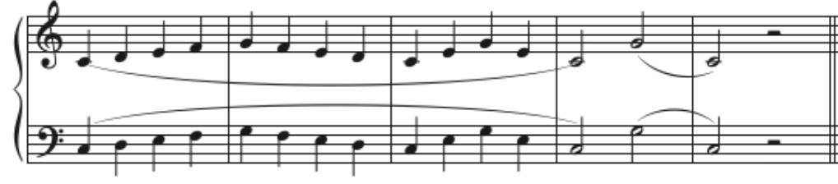

Figure 1. A common five-finger pattern

**Subheading Text**

A content paragraph can go here.

Table 1. This is the title of the table

|  |  |  |
| --- | --- | --- |
|  |  |  |
|  |  |  |
|  |  |  |

The conclusion paragraph can go here.

**Endnotes**

[1] First Name Last Name, “Title,” *Journal Name* 0, no. 0 (Month Year): 00-00.

[2] First Name Last Name, *Book Title* (City, State; Publisher Name, Year), 00-00.

**References**

Last Name, First Name. *Book Title.* City, State; Publisher Name, Year.

Last Name, First Name. “Title.” *Journal Name* 0, no. 0 (Month Year): 00-00.